Insider Trading analysis on Enron Email

Group 15
bruan8@gatech.edu sliu654@gatech.edu
sli711@gatech.edu hxiao73@gatech.edu
Abstract—This paper will explore approaches and find related emails to address the Insider Trading by analyzing the Enron email corpus which was released by FERC. In particular, the proposal will define the wrong doing, explain the signs of email to address the wrongdoing, strategies on how to analyze the emails, the final result emails we found, potential improvement in future and analysis of the method effectiveness.

WRONGDOING: Insider trading
There are many fraud activities regarding the Enron Scandal. For example, securities fraud, money laundering, wire and mail fraud etc. For this project, We would like to focus on insider trading. According to Investopedia, insider trading is the buying or selling of a publicly traded company’s stock by someone who has non-public, material information about that stock [1]. More specifically, a detailed definition of “insider” is as follows. Insiders are a company’s offices, senior managements, and any beneficial owners of more than a certain ratio of the company’s stock. Abnormal trading behaviors from this group of people would be potentially considered as insider trading.
Professor Jeffery mentioned this type of fraud in the class video. This is very straightforward to understand as it will be very unfair to other investors if an insider gains a large amount of profit by taking advantage of nonpublic information. They could buy a large amount of stocks and gain profit if they knew the company’s stock would increase significantly while other investors do not know about it. They could also sell a large amount of stocks and gain profit if they knew before the public that the stock price would drop significantly.

The second option above was conducted by Enron’s executives during Enron's collapse. Just before news of the company's financial crisis, beginning in April 2001, several executives, knowing that the company's stock would take a dive soon. They sold much of their stock before it started to plummet. By selling their shares (Jeff Skilling, the company’s CEO made $67 million in Enron stock between 1998 and 2001), 29 executives engaged in what is known as insider trading [2]. Even in September of 2001, just before the stock collapse, Enron Chairman Kenneth L. Lay talked positively about Enron in the employee forum and urged employees to buy stocks. Enorn’s stock was at the peak of $90 in August 2000, closed at around $25 on Sep.26 and worthed $4 a month later. Eventually the company filed bankruptcy and the stock closed at 51.5 cents [3].

Another way is to look at the size of the trading. If the trade amount is small, even if it occurs before the breaking news, it is not likely an insider trading. It could be regular trading behavior by normal investors. If the traded amount is very large, this trading needs some more attention to investigate.Besides, we should look at the person who makes the trading. If the person is a senior management of the company, any large amount of trading would require some attention.

STRATEGIES TO ANALYZE EMAILS
Now We explain the strategies to find these emails one by one based on the
previous four criteria to identify the insider trading:

1. To find the name of the top Enron executives using email data, we can use
network analysis as stated before. Since employees usually have most
frequent emails with their direct reports as well as other working levels
colleagues, the whole company structure can be represented as a graph. We
can leverage the graph data structure to find the top executives who have
the most connections. Python library networkx is a great tool to leverage.

2. Get a list of potential POIs who might be involved in or reveal the wrongdoings. Firstly we will analyze the timeline and separate it into different stages. To get the list of POI, we can use the elastic search queries to filter all emails by different stages, then group by senders or recipients and sort to get the lists of people who communicate most frequently with top Enron executives.

3. To find emails indicating the Enron executives had been aware of the
company financial situation before selling the stocks. We need to first filter
emails on the time window (before the stock collapses) and also filter to
have only the emails sent to the top executives found in the first step. We
can use machine learning / Natural Language Processing (NLP) tools to
find emails with the terms of interest, such as ‘disastrous’, ‘financial’,
‘implosion’, ‘collapse’, ‘stock sale’ etc.. Using this approach, we can quickly
collect emails that could potentially contain the important information
regarding the Enron financial situation among top executives. Then, we can
manually check to see whether we can spot the evidence of insider trading.

4. Similar as previous strategy, to identify whether the Enron executives urged
employees to buy stocks just before the company stock collapsed. We could
first select email candidates based on the to and from person as well as
the time window. Then We could leverage the NLP tool to do Sentiment
analysis to find emails with frequency of terms such as ‘positive outlook’,
‘buy stocks’, ‘family and friends’, ‘fundamentally sound’ etc. as mentioned
Earlier.

5. Finally, for stock trading information of top executives, We believe we need an extra dataset other than emails to find the financial information. However,
we could also do some sentimental analysis in email based on terms such
as ‘sell stocks’, ‘transaction’, etc to see whether we can find something.

FIND POTENTIAL POIS TO ANALYZE THE EMAILS
Initially we found emails of three key Enron executives: CEO Kenneth Lay, COO Jeffrey Skilling and CFO Andrew Fastow. We would like to locate the role of those three executives in Insider Trading and find out the POI (People of interests) chain who helped them carry out this wrongdoing.

For the Enron timeline we separate it into two phases:

Stage 1. 2000-01-01 to 2001-08-14: Period between Enron stocks at peak and the data that second CEO Jeff Skilling resigned suddenly.
Stage 2. 2001-08-14 to 2001-12-12: Period between Jeff Skilling resigned and The Securities and Exchange Commission opened an inquiry into Enron’s accounting.

Now we will identify the top 3~5 people who communicate most frequently with each of three executives during stage 1 and stage 2. To help us count the people more precisely, we will analyze the emails which are sent to executives and who receives the emails. Technically we use the elastic search with a filter range to get all receiving emails for a period. An example query along with the recipient's term could be like the following format.
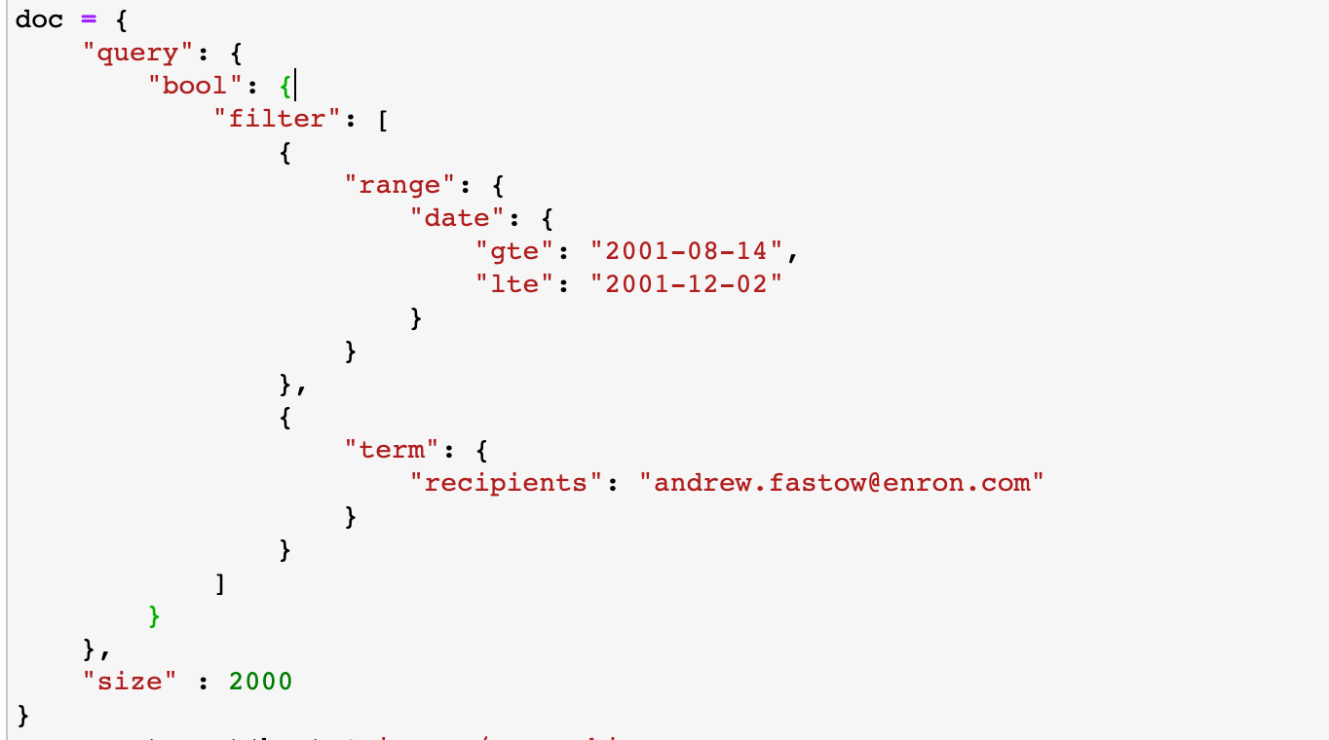
After collecting received emails, we use the python pandas groupby function to sort the top 3~5 people who communicate most frequently with POIs.
An example pandas group function to sort by sender:
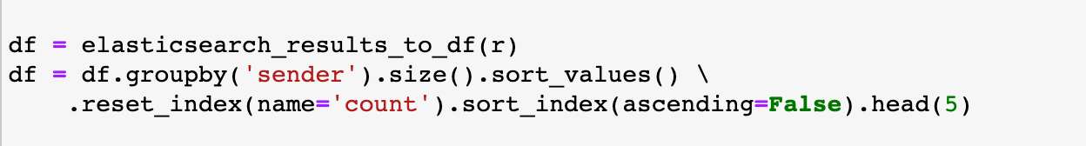
The top 3~5 people in stage 1 are:
Receipt | kenneth.lay@enron.com | jeff.skilling@enron.com | andrew.fastow@enron.com
Potential POIs | steven.kean@enron.com | alhamd.alkhayat@enron.com | vince.kaminski@enron.com
Potential POIs | rob.bradley@enron.com | david.delainey@enron.com | steven.kean@enron.com
Potential POIs | karen.denne@enron.com | jeffrey.shankman@enron.com | john.lavorato@enron.com
Potential POIs | joe.hillings@enron.com | perfmgmt@enron.com
Potential POIs | mark.lay@enron.com | vince.kaminski@enron.com

The top 3~5 people in stage 2 are:
Receipt | kenneth.lay@enron.com | jeff.skilling@enron.com | andrew.fastow@enron.com
Potential POIs | j..kean@enron.com | john@pgsenergy.com | rick.buy@enron.com
Potential POIs | cindy.olson@enron.com | hema@izhuta.com | john.brindle@enron.com
Potential POIs | diana.scholtes@enron.com | news@real-net.net | news@ibcuk.co.uk
Potential POIs | stanley.horton@enron.com | benjamin.rogers@enron.com | info@votenet.com

After generating the list of potential POIs, we could run an elastic search query with sort of potential wrongdoing keywords on those people and related email addresses, then analyze the suspicious emails which could be related to Insider Trading.

SET OF EMAILS THAT INDICATED WRONGDOING
We use an elasticsearch query with the potential POIs as sender/recipients, then we search for emails in the different time ranges according to the Timeline of Enron. The example source code is given as below:

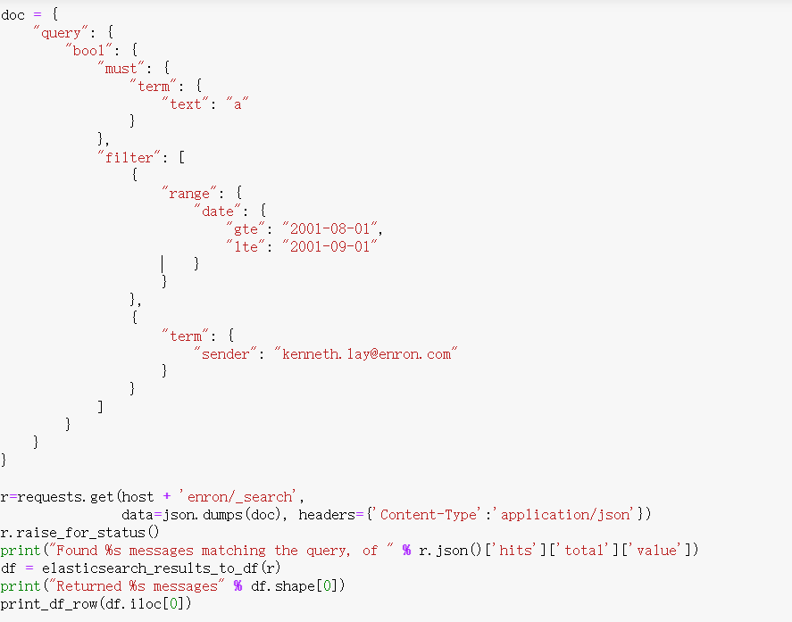
Figure 1. Elastic search query in certains time range

Top 5 emails with key words indicating wrongdoing using elastic search query are listed as below:

At: 2001-08-14 22:27:42+00:00
From: sherron.watkins@enron.com
To: rick.buy@enron.com
CC: nan
BCC: nan
Body:
Wow - you are really busy if your lunch calendar is booked for the remainder of the month! Sept. lunch sounds good. I sure hope we make good use of the bad news about Skilling's resignation and do some house cleaning - can we write down some problem assets and unwind raptor? I've been horribly uncomfortable about some of our accounting in the past few years and with the number of 'redeployments' up, I'm concerned some disgruntled employee will tattle. Can you influence some sanity?

Email 1. Evidence indicates the Enron executives had been aware of the
company financial situation before selling the stocks

At: 2001-08-18 00:55:53+00:00
From: j..kean@enron.com
To: kenneth.lay@enron.com
CC:
BCC:
Body:
I know you are getting an impossible volume of advice right now . . . but that's not going to stop me from piling on a little more.

I believe everything we have been saying: we have the best business model, we are making great money, we are growing, we are addressing our issues and we have all of our capabilities intact. We are poised for even greater growth. Even so, we will not be able to fight off the negatives on our stock and on our reputation right now. Our problem is not a problem about getting the message out.

Part of the problem we can't do anything about: almost all equities have suffered this year. But part of our problem (the part we can do something about) is that we are faced with too many bad, but true (or at least plausible), allegations that we have to deal with every time we try to tell our story. These current circumstances are not necessarily bad: I think we can use them as a great opportunity to drive some overdue changes. But no amount of communication or "spin" will work right now. We have to directly address the issues.

The difficult allegations we face include:

Creative or aggressive accounting (both in reporting and deal structuring);
Black box reporting;
Over-hyping of the stock or the prospects for unproven businesses;
A near mercenary culture which encourages organizations to hide problems (until those problems have become very big), discourages cooperation and teamwork, and drives off people who demand at least a modicum of civility in their work environment.

I have some answers. First, I would hold our actions to the standard we apply to everything else: the market standard. We should do the economically rational thing in every transaction and business and let the chips fall where they may. Instead of tying ourselves in a knot about managing earnings or write downs or avoiding an asset sale because it's on the books for more than the market, we should just make the rational economic decision.

Second, I would open up our reporting. Make it as transparent as the analysts want; indeed, set a new standard for transparency and integrity. I know we are looking at these things and have been for some time. I also realize that at some levels of disclosure we risk disclosing positions. I'm just saying we should drive right up to the edge.

Third, I think IR should be all about the facts: disclosing facts and correcting misunderstandings. I would not "spin" in this function. Our audience is too sophisticated. If we make the economically rational decisions over and over, the stock price will come along. We have lost credibility by overhyping businesses we haven't proven yet and it's hard to see why we do it. To get early credit in the stock price? I'd rather wait. To prove that we are a growth company? I think a track record of growth and a rational and circumspect discussion of our opportunities will take care of that. I want us to be a company which is bold in its business moves, not in its approach to analysts or in its accounting. The reputation I would like to have with investors is that we never overstate, we never dissappoint and that we can always be trusted. I am not being critical of our team. We have the best, most organized, hardest working, and most effective IR team in the business. I am just concerned that we have sent them speeding down the wrong path. Similarly, I am not critical of our accounting organization. We have the finest accounting organization in the industry. They need to be the best in order to get sensible accounting rules and interpretations to accurately reflect the results of our unique and innovative business. They need to minimize our tax exposures etc. I am not arguing that anyone has done anything wrong or ineffectively. I simply believe that it is time to reassess how we do these things (and I don't consider my organization to be exempt from that same reassessment).

Finally, our culture. As I said the other day, there may be a relatively small number of individuals who are commercially successful, well paid, regularly promoted who have little or no respect for their coworkers or other human beings in general. When others see them rewarded, it matters not at all what we say about our values. Dealing with a few people directly will send a message that spreads like wildfire through the organization. Additionally, compensation structures and a PRC process which explicitly rewards teamwork (and which includes broader representation than just the commercial groups) will go a very long way toward changing the level of civility in the organization.

I hope it's clear to you that I love this place. I have poured my heart and soul into it. It is the finest organization I have ever been part of. Like everyone, I have had some time to reflect lately. I have recommitted myself to this place and to your leadership. Part of that recommitment will be my concerted effort to make things even better.

Email 2. Evidence indicates the Enron executives had been aware of the
company financial situation before selling the stocks

RE: 2001 Special Stock Option Grant
At: 2001-08-28 03:16:29+00:00
From: ken.lay@enron.com
To: mike.swerzbin@enron.com
CC:
BCC:
Body:
MICHAEL SWERZBIN:

As promised, I want to update you on the Special Stock Option Grant that I announced at the all-employee meeting.

You have been awarded a stock grant as follows:

Special Stock Option Grant
Grant Date: August 21, 2001
Grant Price: $36.88
Vesting: Options are 100 percent vested on date of grant
Number of options: Based on 5 percent of an employee's annualized base salary as of August 13, 2001 and a theoretical stock option value of $15. You will be notified of the actual number of stock options awarded to you.
Option Term: Five years
The terms and provisions of this grant are subject to the applicable 1991 or 1994 Enron Corp. Stock Plan, as will be referenced in the stock award agreement.

Employees who are eligible to participate in this special program will receive award details in the next several weeks. More information about this grant will be available on the HR web site http://hrweb.enron.com.

As I mentioned at the employee meeting, one of my highest priorities is to restore investor confidence in Enron. This should result in a significantly higher stock price. I hope this grant lets you know how valued you are to Enron. I ask your continued help and support as we work together to achieve this goal. Again, on behalf of the Enron Board and myself, thanks for everything you are doing to make Enron the great company it is. And stay tuned for regular updates from me about what is happening around Enron.

Ken

Email 3. Enron executives urged employees to buy stocks and predict “significantly higher stock price” just before the company stock collapsed

RE: Associate/Analyst Program
At: 2001-08-23 18:24:25+00:00
From: kenneth.lay@enron.com
To: Associate/Analyst Program Worldwide

From: Ken Lay Department: Office of the Chairman

Subject: Associate/Analyst Program Date: August 22, 2001

As most of you know, Jeff Skilling created the Associate/Analyst Program in 1990. This Program is one of his most successful and important contributions to Enron, and will continue as a cornerstone of the Company. It remains our single most important source of new talent.

The purpose of this memo is to reassure you that the direction, philosophy, and importance of the Program remains unchanged. As we have said many times, most of our new businesses were created by graduates and members of the Program. Many of the current leaders of our company are also graduates of the Program.

Three broad principles will continue to guide the direction of the Program.
? We will have only one Associate/Analyst Program at Enron, and it is a Company asset.
? We will have a "One Enron" presence on campus to provide clarity of message and purpose.
? The Program is rotational in nature, and will prepare our future leaders for success by providing exposure to Enron's network of people and systems.

The business prospects for Enron, and the opportunities for personal growth and development have never been better. We also enjoy the deepest and broadest talent pool we have ever had. Each and every one of you can be a key contributor to making Enron the World's Leading Company.

cc:
Billy Lemmons - Associate/Analyst Program
John Sherriff - Associate/Analyst Committee Chair
Management Committee
Associate/Analyst Committee
Associate/Analyst Department
Human Resources Leads
Program PRC Reps
Program Supervisors

Email 4. Evidence indicates the Enron executives hiding the information about account issues and encouraged employees to make contribution to Enron

At: 2001-08-29 13:26:10+00:00
From: kenneth.lay@enron.com
To: pamela.j.allison@dynegy.com
CC: nan
BCC: nan
Body:
Dear Pam:

Thank you for your e-mail of August 15th. It is always a pleasure to hear from former employees. Thank you also for calling attention to instances which, on the surface, do not appear to be representative of our expectations of Enron leadership.

Part of our continuous improvement involves an on-going review of our management and the diversity of styles therein. True, not everyone is agreeable to Enron's culture or the many different management styles at Enron. We do, however, expect all of our employees - not just management - to adhere to our core values of respect, integrity, communication and excellence. These values become even more significant as we continue to grow and expand our scope of business, and more critical as we become a more culturally diverse workforce.

We enjoy our status as one of the best places in America to work according to Fortune and other sources thanks in part to our willingness to examine our organization and make needed change. Our employee surveys, belief in open communication, and exit interview process for employees choosing to leave Enron are examples of our efforts to seek out feedback and scrutinize the way we do business. Your feedback will help play a role in that process.

Sincerely,

Ken Lay

Email 5. Evidence indicates the Enron executives still hiding the information after receiving an email from former employee

Was your set of emails good? Why or why not?
We successfully narrowed down the emails to a targeted date range as well as its recipients. Although the senders included people not in our table of POIs, they all contain evidence of the company’s misconduct as acted out by the top executives and experienced by lower level employees. In other words, our emails told a consistent story of Enron’s wrongdoing.

Email 1 is a direct email from Sherron Watkins to Rick Buy about Jeffrey Skilling’s resignation and how to relocate employees. Both Watkins and Buy were higher management in the company. Skilling was Enron’s CEO and his resignation would have sent red flags to many of Enron’s partners and investors. Email 1 is short but is solid evidence that Enron’s executives knew of its “problem assets”, accounting problems, and the company’s need for “house cleaning”.

Email 2 is from Steven Kean, Enron’s chief of staff, urging Kenneth Lay to make Enron’s accounts transparent despite the company’s losses. Kean’s statements provide evidence that executives knew “almost all equities have suffered this year”, and his advice to make Enron’s accounting as “transparent as the analysts want” meant it previously wasn’t. He also criticized the company’s corporate culture as well as its focus on managing capital instead of doing business. Email 2 reveals a lot of the company’s bad practices: blackbox reporting, over-promising in stock for early credit, and mismanaged assets. Kean’s email is overall strong evidence for Enron’s market manipulation and accounting fraud.

Email 1 and 2 have already shown that the executives know about the company’s bad accounting, but they are still telling employees that the stock price will go up. However, the executives’ behavior contradicts their statements. Email 3 contains strong evidence of Enron’s securities fraud against its own employees, because the CEO is telling employees to hold or buy Enron’s stock with a promise that it will increase. As the stock is losing investor confidence, we see the effects of his comments with a slight spike in the stock in September before the entire stock crashed, suggesting market manipulation.

In Email 4, Lay also publicized a career development program the day after to boost employee confidence in the company’s longevity. External resources indicate that Kenneth Lay sold $2 million worth of shares on August 20, 2001. The sale suggests that Lay himself has already lost confidence in the company’s stock, so asking his employees to buy or hold is deceptive.

Email 5 deflects an ex-employee’s concern about the company’s abusive corporate culture, again misleading Enron’s stakeholders. However, this Email is a generic response to an ex-employee’s concerns and doesn’t show any sign that the company takes its insider criticisms seriously. Email 5 isn’t as strong of evidence as the other emails, because it doesn’t address anything related to Enron’s financial practices and only demonstrates Enron's culture of self-preservation.

Our strategy would provide an extensive look at the knowledge and communication at various operating levels of the company and a firsthand account of Enron’s downfall. These emails show evidence of the insider trading and its misleading corporate culture of continuing its bad practices. The set of emails show the inconsistency between what the executives knew and the image they projected to its employees through career development programs, attempt to maintain their stock options, and responses to employee’s criticisms.

External information
The external information of Enron stock price is given in Figure A. After Kenneth Lay and the top executives realized the issues in the accounting report and financial situation as Email 1 and 2 showed, Kenneth Lay sold 93000 shares for about 2 millions on August 20, 2021, and he sent an email to an employee and predicted “significantly higher price”. The external information together with Email 3 give us the evidence of insider trading made by Kenneth Lay.
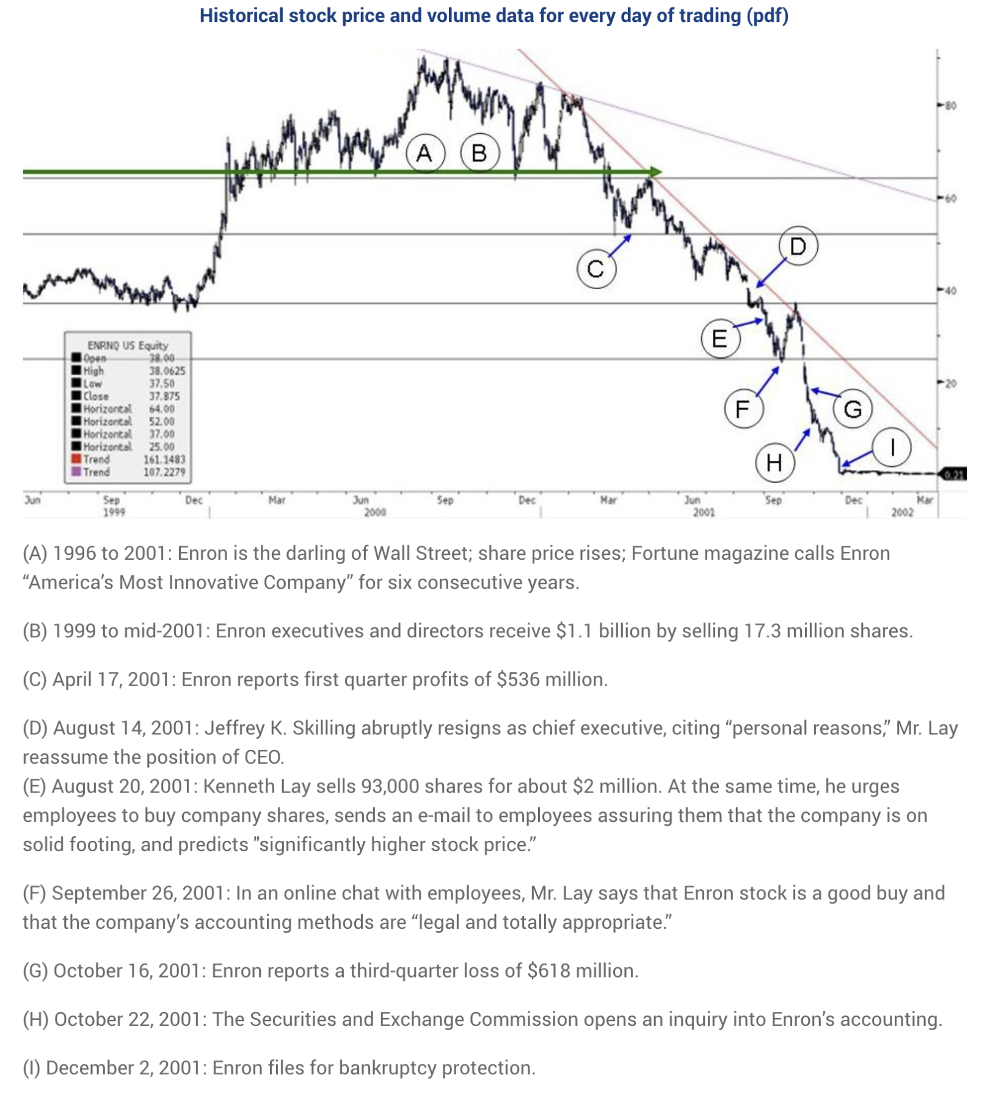
Figure A. Enron Stock Price Chart And Timeline

What problems would you fix next time?
Based on the external information, we found that Enron top executives sold 93000 shares on August 20, 2001, but we haven’t found any email indicating the evidence of stock trading using the query. Next time, we are going to adjust the keyword and search more carefully to have the information for the stock trading made by each top executive.

What problems are unfixable about this approach?
The problem for this approach is that we need to set the keywords and adjust them manually. Later on we can use other machine learning approaches to set the keywords differently and compare the performance.

REFERENCE
1. https://www.investopedia.com/terms/i/insidertrading.asp
2. https://money.howstuffworks.com/insider-trading.htm
3.https://www.latimes.com/archives/la-xpm-2002-jan-19-mn-23640-story.html
4. https://www.nbcnews.com/id/wbna11839694

